LAB 8 OOP TASK
Hania Imran 25k-0523
Q1:
#include <iostream>
using namespace std;
class Device {
protected:
string ID;
string type;
double power;
bool status;

public:
Device(string i,string t,double p):ID(i),type(t),power(p)
{status=false;
}
string getID()
{return ID;
}
virtual void turnOn()
{status=true;
}

void turnOff()
{status=false;
}

virtual double calcpower(int h)
{return power*h;
}
};
class Light:public Device{
public:
Light(string i,string t,double p):Device(i,t,p)
{}
double calcpower(int h)
{return power*h;
}
void turnOn()
{status=true;
cout<<"Turn ON"<<endl;
}
};
class Fan:public Device {
int speed;
public:
Fan(string i,string t,double p,int s):Device(i,t,p)
{speed=s;
}
void turnOn()
{status=true;
cout<<"Turn ON"<<endl;
}
int getspeed()
{return speed;
}
double calcpower(int h)
{return power*h*speed;
}
};
class AC:public Device{
double ct,dt;

public:
AC(string i,string t,double p,double tt):Device(i,t,p)
{ct=tt;
dt=25;
}
double getdt()
{return dt;
}
void turnOn()
{status=true;
cout<<"Cooling:"<<dt<<endl;
}
double calcpower(int h)
{ return power*h*(1-(ct-dt)/100);
}
};
class MT;
class SecurityS:public Device{
bool alert;
public:
SecurityS(string i,string t,double p):Device(i, t, p)
{alert=true;
}
void turnOn()
{status=true;
cout<<"Activated"<<endl;
}
void turnOff()
{status=false;
}
double calcpower(int h)
{return power*h;
}

friend void accessSecurityLogs(SecurityS s);

friend class MT;
};
class MT{
public:
void reset(SecurityS &s)
{s.alert=false;
}
};
void accessSecurityLogs(SecurityS s) {
cout<<"User:"<<s.getID()<<"-Security Log Accessed\n-Instrusion Detected at:3:00am\n-System Reset Required\n";
}

class User{
string ID;
string role;
int level;

public:
User(string i,string r,int l)
{ID=i;
role=r;
level=l;
}

void viewDevices()
{ cout<<"User:"<<ID<<"-Accessible Devices:"<<endl<<"-LED Light\n-Ceiling Fan\n-Split AC"<<endl;}
};
int main()
{User u1("U001","Regular User",1);
User u2("U002","Maintenance Staff",2);
Light l1("L001","Light",10);
Fan f1("F001","Fan",75,3);
AC ac1("AC001","AC",1500,25);
SecurityS s1("S001","HomeAlarm",100);
cout<<"LED LIGHT\t"<<l1.getID()<<"\t";l1.turnOn();
cout<<"FAN\t"<<f1.getID()<<"\t";f1.turnOn();
cout<<"AC\t"<<ac1.getID()<<"\t";ac1.turnOn();
cout<<"HomeAlarm\t"<<s1.getID()<<"\t";s1.turnOn();
cout<<endl;
cout<<l1.calcpower(5)<<endl;
cout<<f1.calcpower(3)<<endl;
cout<<ac1.calcpower(6)<<endl;
cout<<s1.calcpower(24)<<endl;

accessSecurityLogs(s1);
cout<<endl;
MT t;
t.reset(s1);
u1.viewDevices();

}
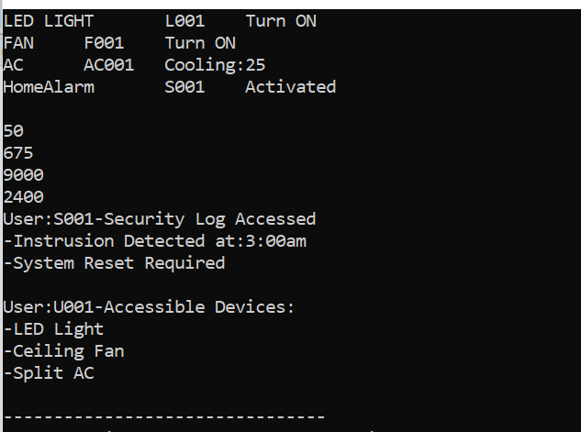
Q2:
#include <iostream>
using namespace std;
class Account {
private:
string no;
string name;
double balance;
public:
Account(string no,string n,double b)
{this->no=no;
name=n;
balance=b;
}

double operator+(const Account &a)
{return balance+a.balance;
}

void operator-=(double amount)
{balance=balance-amount;
}

bool operator>(const Account &a) {
return balance>a.balance;
}
void deposit(int d)
{balance+=d;
}
double getbalance()
{return balance;
}

friend ostream& operator<<(ostream& out,const Account &a);
};

ostream& operator<<(ostream& out,const Account &a) {
out<<"Account Number:"<<a.no<<" Holder:"<<a.name<<" Balance:"<<a.balance<<endl;
return out;
}
int main()
{Account acc1("101","John Doe",5000);
Account acc2("102","Alice Smith",3000);
int total=acc1+acc2;
cout<<"Total Balance:"<<total<<endl;
acc1-=2000;
acc2.deposit(2000);
cout<<"After Transfer"<<endl<<"John Doe balance:"<<acc1.getbalance();
cout<<"\t Alice Smith balance:"<<acc2.getbalance()<<endl<<endl;
if(acc1>acc2)
cout<<"John has more balance than Smith\n";
else
cout<<"John has less balance than Simth\n";
cout<<"\nFinal Account Details:\n";
cout<<acc1;
cout<<acc2;

return 0;
}
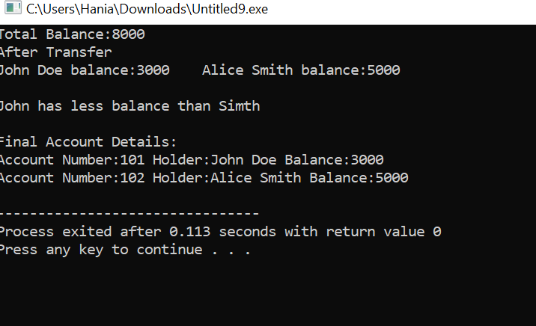
Q3:
A member function only works when the left hand operand is an object but a friend function can take both operands as parameters.
#include <iostream>
using namespace std;
class A{
int a;
public:
A(int a)
{this->a=a;}
int geta()
{return a;
}
friend A operator+(int b,A a1);
};
A operator+(int x,A a1)
{return A(x +a1.a);
}

int main()
{A obj(10);
A result=5+obj;
cout<<"Result:"<<result.geta();
}
LIMITS:
- If no object is passed and the function tries to access non-static members
- If the function is not declared as a friend
- If access is attempted incorrectly
Q3:
A friend function can access private and protected members of a class, but it usually needs an object of that class to access them. If it is a non-static member, it needs object if a static member, so it does not need any object.
#include <iostream>
using namespace std;
class A{
int a=10;
public:
friend void display(A no);
};
void display(A no){
cout<<no.a;
}
int main()
{A obj;
display(obj);}

